**Prototype One**

* **Notes on general UX!**
  + **Let color simplify the UI**. A key color—such as yellow in Notes—highlights important state information and subtly indicates interactivity. It also gives an app a consistent visual theme. The built-in apps use a family of pure, clean system colors that look good at every tint and on both dark and light backgrounds.
  + **Embrace borderless buttons**. By default, all bar buttons are borderless. In content areas, a borderless button uses context, color, and a call-to-action title to indicate interactivity. And when it makes sense, a content-area button can display a thin border or tinted background that makes it distinctive.

Issues with Message threads/Requests

* Do rent requests live within message threads, or vice versa? Or are they two separate entities?

The rent requests live within the message threads -- this is at a user to user level. So if the same user later rents another dress from the same renter, there is an existing background to their previous interactions. Or even if a rentee rents many dresses at once, then all the requests should show up within the same message thread.

* + If requests live in messages, what happens when a user wants to request multiple items? Can they do that?

Yes they can, maybe we can cap it to 3 requests per rentor -- that way we can maintain the trust amongst users

* + If messages live in requests, are they organized by user or by item? (i.e. all requests for one item can be found by navigating to that item, or all requests by one person can be found by navigating to user?)

All requests can be found by navigating to that person -- this will be better to implement in the backend

* + Are rent requests/messages categorized by user, or by item?

By user -- Not sure how Airbnb looks on the rentor side, **do all the requests stay in message box forever? Or do they disappear ?**

* Do requests flow within conversation of a message thread, or does one box appear at the top of each message thread saying “Request Accept/Reject”, then when accepted transitions to “Request Accepted, Item returned on xyz”, then on xyz the box transitions to “Has item been returned? Y/N”, and then transitions to “Complete”

I envision 3 parts to a rental transaction : 1) the request (renter must confirm or deny) 2) the actual exchange (both parties must confirm that the exchange occurred) 3) the return (both parties must confirm that the exchange occurred)

I would want those prompts to be at the top of the message (and follows through with the whole message, so more like a header… changes after transaction response) and the actual detail of the part occurring shows up in gray (ex. Shivi accepted Juliana’s request, prompt now changes

* + IF SO, what happens after that? Is the thread dead?

Good question -- I think that they should disappear since we are expecting users to be rating each other so there is a way to track which rentees renters have engaged with and vice versa

* Feature to add: A review prompt after a completed transaction (maybe just stars for multifaceted qualities like : friendliness, punctuality, cleanliness, communication, ease of interaction things + a space for short review
  + - RE: Should message requests live in threads, sorted by user?

Yes, at a user level

* + If request boxes appear within message thread chronologically, do you have to scroll to see which requests are active and which are not? Scroll to see accepted/rejected? What if multiple items requested; chronological boxes might get confusing.
    - RE: How to manage multiple requests by one user

A new Request box should be created for each item ( remember each dress has a name associated with it) . That means if a user requests to rent out more than one dress then there should be multiple requests (one for each dress) in the thread which change based on whether each individual request is accepted or rejected by the rentor

* Air BnB:
  + Seem to be organized by room/place. Messages filed under room, by user. Request acceptance details found at top of messages.

Hmm, maybe for the prototype it would be easier to visualize it at a user level ?

Random

* Search function:
  + On bottom bar in place of new post?
    - New post only available on profile

Sure! For the new post have it like the (+) button on facebook messenger app when you go to the main part and can see all the threads you have active? So a stand alone button in the corner that exists in the home, profile and search pages?

* + On home screen at top (search bar)
  + Search by username, tags, categories?

Items will be tagged and given a description (see the “prototype tech” doc in the “Technical” folder). Tags can include things like #girlsnightout, #boozybrunch etc.) . Would not be an exact word for word search (to account for the use of hashtags, think instagrammy search)

* + Basic boxes of categories? (Dresses, Tops, Sweaters, etc)

Starting with dresses as of now (for alpha development) but want to get into whole outfits in the future . Maybe can add outfits in the visual rep?

* Tagging?
  + Anything? Colors? Etc
  + Usernames?

Users will be making accounts with their FB, so no need for usernames -- should be their FB name

* + Category?
* Profiles
  + Follow function?

Yes so you can follow a “boutique” closet if that style really vibes with yours! This will also help with the newsfeed algorithm

* + Message function directly from profile? Or only when in a request?

Option to message owner when click on a dress that you like or when on the renters profile page . Can ask questions without a request

* + Search within profile? User’s posts? Or just scroll.

Search will be able to work on the whole and within a renter’s boutique. The boutique should have an option for viewing all listings and tabs for “Dresses”, “outfits” … because in the future I can envision people sharing items like handbags and accessory pieces as well!

* + How many/what are the things a person will want to do on their own profiles?
    - Edit:
      * Bio
      * Profile picture
      * Description of self (short, think Twitter or Instagram )
    - Add/Remove items for rent
    - Edit existing items
    - View reviews given and received
    - Anything else??
* How is the rentee profile handled?
  + A name, description, profile picture, but what else in place of the closet?
  + “This user does not currently have a closet!”

Ya just an empty space with perhaps a watermarked hanger image saying “closet coming soon” or something

Pictures on profiles/posts:

* + Can picture be clicked and enlarged, then still scrollable?

Yes, brilliant! Swipe scroll to the left and right, Tinder-ish to see available pics but the max is 3

**Plan Layout**

---*Buttons on App Footer*

* ---Home
* ---Your profile
* ---Search
* ---Likes
* ---Messages

*From a UX perspective is this too cluttered or does it just enough?*

**HOME PAGE**

* ---Default/open page
* ---App title appears on top of this page
* ---“Newsfeed” style: displays items from closets the user follows

*---As such:*

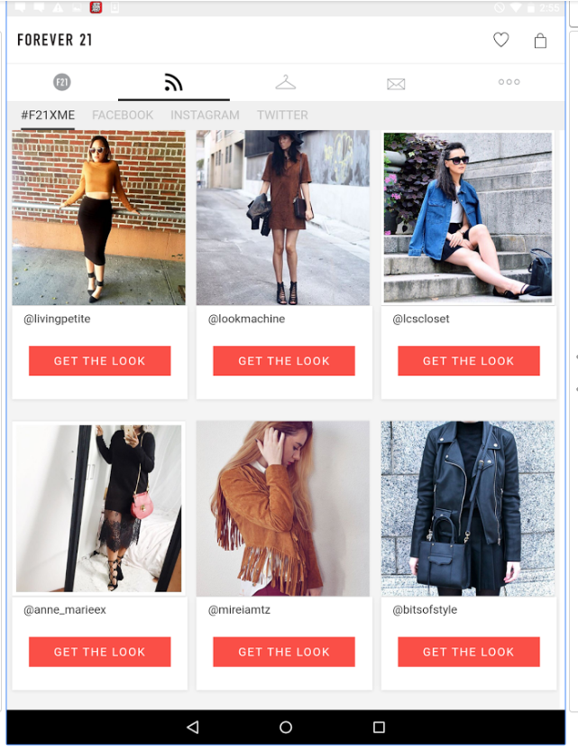

* ---Items displayed on ITEM’S IN GRID

*Functions from homepage:*

* ---Ability to interact with posts:
  + ---Click on a username and be directed to their closet
  + ---Click on a post/image and be redirected to the post’s individual page
* ---Ability to navigate to Profile, Search, Likes, Messages

**YOUR PROFILE**

(Displayed like User Profile, +Edit Options, -Interaction Options)

* ---Header info:
  + ---Picture
  + ---Name
  + ---Short bio
  + ---Location

*I like this look (Bumble pic below) + the inclusion of shared friends (which would be easy to implement given FB interaction. It is short + simple. Would change it so the pic and info is a very small aspect. Star ratings and review snippet included. Then links out to the closet? Not sure if we should have it scroll down to the closet or have the closet a separate window. Originally I had it set up as the profile and closet are in the same screen (think Instagram or Kidizen) and I think that is simpler but I am not sure how to implement all this info into that one screen*

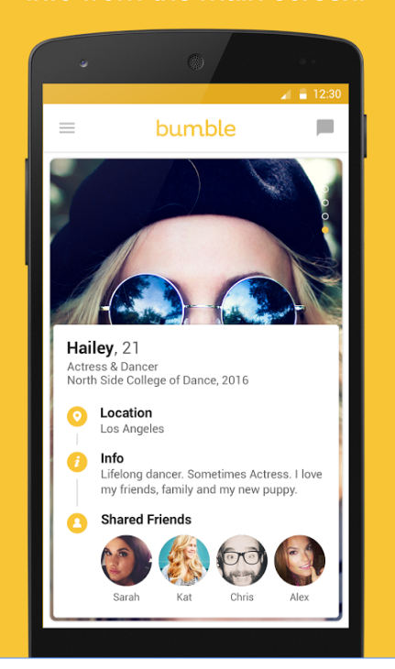

***Functions of User Profile***

* Edit profile/info
* Ability to add a post
* Ability to select existing posts
  + Redirected to individual item page, where they have the ability to edit individual posts
* Ability to view followers
* Ability to view following
* Ability to view Reviews
* Ability to search for posts within own profile

*Edit Profile*

* ---Navigate to by clicking Tools button upper right corner
  + ---“Edit profile”
  + ---“Logout”
  + ---“Cancel”
* ---Edit profile functions:
  + ---Edit bio
  + ---Edit location
  + ---Ability to click on or off “Show location on profile” (privacy?)

*Add a post*

* By clicking on [+] button in upper left corner
* Functions of “add a post” page:
  + Upload 1-3 pictures from **Facebook profile or Camera Roll**
  + Fill out required information using keyboard
    - Item name
    - Size
    - MRP
    - Brand name
    - Rental price
    - Item info (description)
      * Up to 180 characters (made up number) to describe fit, feel, style of dress
    - Model info
      * Height
      * Bust
      * Waist
    - Add tags (using hashtag function to separate tags)
  + Share post
  + Cancel (go back)

*Edit existing posts*

* Click on post from your closet/timeline and it opens in it’s own window
* Ability to:
  + Upload new photos/delete existing photos
  + Edit all text fields
  + Add/remove tags
  + Save
  + Cancel (go back)

*Should be able to edit the name of the dress, rental price, retail price, brand*

*View…*

* Followers
  + Click on “# followers”
  + Redirects to page with list of users+profile pictures, linking to each profile
* Following
  + Click on “# following”
  + Redirects to page with list of users+profile pictures, linking to each profile
* **Reviews**
  + **Click on “# Reviews”**
  + **Redirects to a page with Your Reviews**
    - **Stars for each category (an average of all reviews)**
    - **Comments from users listed below**
      * **Username, comment**
  + **Clicking on a specific review expands that review into it’s own window**
    - **View username, comment, and star ratings**
      * **Ability to open user’s profile by clicking on name**

*Search within your profile*

* Search bar underneath header of profile
  + “Search xxxx’s Closet!”
  + Click in search bar and search by item name/color/tag
* Posts reorganize below to only show relevant posts
  + Same window, just updated
* “Go back” by deleting words in search bar
  + Window reorganizes back

**SEARCH**

Instagram-Style

*Search functions:*

* Search is started by clicking on search icon in footer
  + Redirects to new page: Search (Instagram inspiration)
* Ability to search by person, **items**, tags
* Searches bring up items same organization as homepage/profile (grid)
  + Posts have same functionality, too

*Search by:*

* Person:
  + List of names to click
  + Clicking names redirects to profiles
* Item:
  + **Search for a type of item (All dresses)**
  + Search for a person’s items
    - Search “Shivi S” by item, brings up posts by Shivi S.
* Tags
  + Brings up all posts with that tag

**USER PROFILES**

*Functions:*

* Follow/unfollow
* Message
* Search user’s profile
* View user’s
  + Followers
  + Following
  + Reviews
* View user’s items/click to expand into item page

*Follow/unfollow function*

* Button at top of profile

*Message function*

* Button at top of profile
* Redirects to New Message screen

*Search within user’s profile*

* Search bar underneath header of profile
  + “Search xxxx’s Closet!”
  + Click in search bar and search by item name/color/tag
* Posts reorganize below to only show relevant posts
  + Same window, just updated
* “Go back” by deleting words in search bar
  + Window reorganizes back
* Header:
  + Picture
  + Name
  + Short bio
  + Location (**optional**)

*For user’s without closets*

* Blurb “This user is not renting any items in their closet at the moment!” in place of items
* Everything else = the same

**LIKES**

* Same functions as homepage, but only items you’ve liked

**ITEMS**

Individual items’ pages

*Accessible by:*

* Clicking on the item’s image/title in grid organizations
  + Via homepage, likes, search function, and user profiles

*Screen*

* Renter's name and profile picture
  + Redirects to user’s profile
* Item title
* Images
  + Ability to scroll between multiple images (left to right)
* Buttons to:
  + Rent
  + Like
  + Message user
  + See more info
  + See likes
* Info:
  + Size
  + Brand
  + MRP
  + Rental price

*Functions:*

* Ability to rent
* Ability to like item
* Ability to message user
* Ability to scroll through pictures, if multiple (left and right scroll)
* Ability to see who likes this post
* Ability to see more info

*Renting an item*

* Pop up bubble (screen does not redirect, but has an object overlaid on current screen)
  + Enter in rental dates
    - From: / To:
    - When click on date box to enter, calendar pops up to select date manually
  + Click “Request” to submit rental request
    - Bubble disappears, “Request submitted!” appears in a bar at top of screen and then dissolves
    - Request sends to other user in a message; new message thread created for each user/updated message thread for each user if thread alrady exists
  + Cancel out of a request
    - Click “Rent” again, bubble disappears/request draft cancels

*Like button*

* Screen does not change; button fills in color
* Adds item to you “Likes” page

*Message user*

* Creates a new message thread for both users without a request popup

*View likes*

* Click on “# Likes”
* Redirected to new page: “Likes”
  + List of usernames and profiles who liked this post
  + Clicking names redirects to user profiles

*Info button*

* Pulls up an overlaid screen including item information
* Information included:
  + Item description (typed by renter)
  + Model description (typed by renter)
    - Height
    - Bust
    - Waist
  + Tags
* “Go back”/cancel out of info screen
  + **X in the corner**
  + **Click outside of screen**

**MESSAGES (and requests)**

* All messages appear in chronological order by username in a user’s message box
* Request notifications come as a message notification: Appear in message threads (new or existing)
  + Multiple requests = multiple request boxes at head of message thread

*Requests*

* Requests appear in a box at top of thread (like a header)
  + For renter: “Blue Velvet Rental Request mm/dd - mm/dd: Accept / Reject”
  + For rentee: “Blue Velvet Rental Request mm/dd - mm/dd: Pending”
  + Messages flow beneath request box
* Accepting a request:
  + For renter: “Blue Velvet Rental Request mm/dd - mm/dd: ACCEPTED”
    - Once navigate out of and back into message thread, box has disappeared and “Blue Velvet Rental Request mm/dd - mm/dd: ACCEPTED” appears in line with messages chronologically
  + For rentee: “Blue Velvet Rental Request mm/dd - mm/dd: ACCEPTED” appears in line with messages chronologically
* Confirming the switch off occurred on the FIRST DAY OF RENTAL: Header box
  + For renter: “Was item delivered? Y/N”
  + For rentee: “Was item received? Y/N”
  + When only one user has confirmed and the other hasn’t:
    - “Waiting confirmation”
  + When both confirmed:
    - “Blue Velvet Dress was recieved”
* Confirming the switch off occurred on the LAST DAY OF RENTAL: Header box
  + For renter: “Was item returned? Y/N”
  + For rentee: “Was item returned? Y/N”
  + When only one user has confirmed and the other hasn’t:
    - “Waiting confirmation”
  + When both confirmed:
    - “Blue Velvet Dress rental was completed”
* Multiple requests render multiple boxes at header per request.

*Request bubble once you hit “Yes” for completion*

* Pop up bubble on screen
* 1-5 star ratings:
  + friendliness, punctuality, cleanliness, communication, ease of interaction things + a space for short review

(Old Comments)

*View Reviews*

* See which users rated what?
* An averaged total stars for each category? *5 stars per category -- overall stars are averaged among the multifaceted categories*
* Pop up window? New window?

*Not sure the best place to put these; I can forsee that when you click on a user’s stars rating, it would take you to a separate reviews view.*

* Stats?
  + Items, Followers, Following
* Include user’s age/body shape/height?

*This is something that users must fill out but wont be displayed on their profiles but maybe this should be placed in the description for user’s dresses/outfit items? Similar to how those “Model is 5’8 wearing size small … “ descriptions are included in regular retailers . No One would really need to know at a profile level, would only need to know after you look at a dress and assume it fits*

* Interactive Functions:
  + Message user > New Message in messages window
  + Search within profile

*Search within a user’s profile*

* Search bar beneath bio/header? *At footer may be better ~~-- not sure about it being the main center button though. I think the “add a dress” should be the center button~~ Having the search as the middle button is perfect!*
* Typing in search bar does not pull up any new pages, but rather updates the grid organization to only display items relevant to search *YES*
* OR, “View by category” option that you can click to be brought to a new page of boutique with grid display of “Dresses” “Handbags” “Outfits” etc, that direct you to a list-organization page of each item in that category *YES ALSO -- but in the future perhaps? As of now focusing on dresses*

Non-Boutique Profile

* How to handle???
* Just picture/bio/location info, with blurb underneath saying “This user does not have a boutique yet!” : Yup! There is no differentiation between the renter and rentee registration yet . However, non-renters can start off by skipping the initial “put up dresses” option

*Screen*

* Renter's name and profile picture
  + Redirects to user’s profile
* Item title
* Images
  + Ability to scroll between multiple images (left to right)
* Buttons to:
  + Rent -- *leads to a calendar view or option to “rent now”*
  + Message renter